Visualization data

Certainly! Displaying datasets using Matplotlib involves plotting data points on a graph where the x and y axes are labeled to provide context for what the data represents. Here's a step-by-step guide to creating a simple plot with labeled axes using Matplotlib in Python

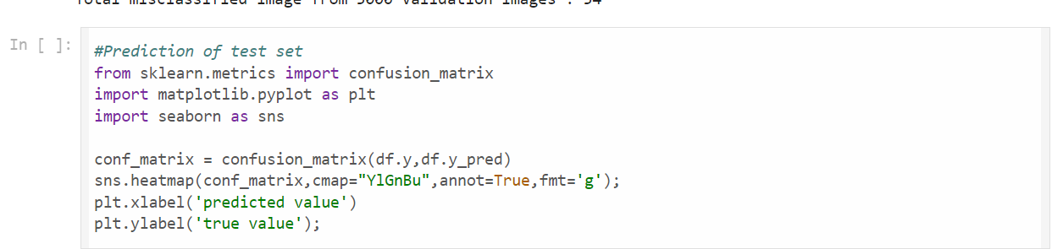 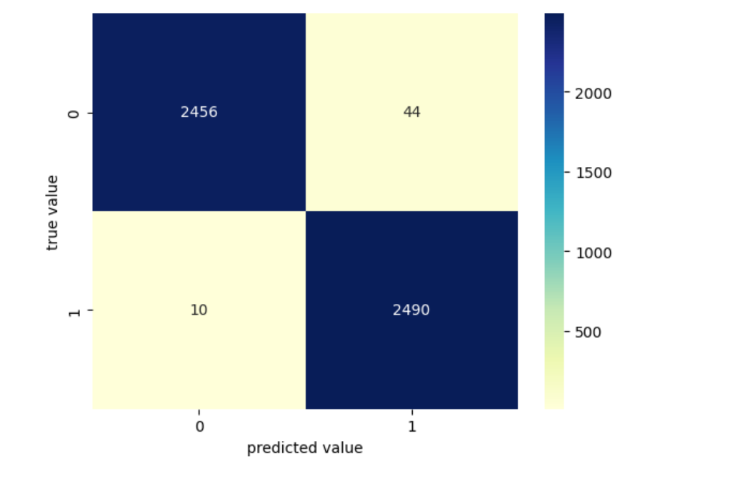

Displaying cats img data

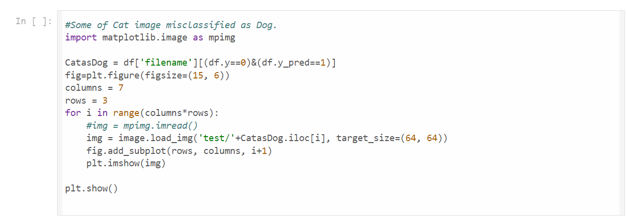

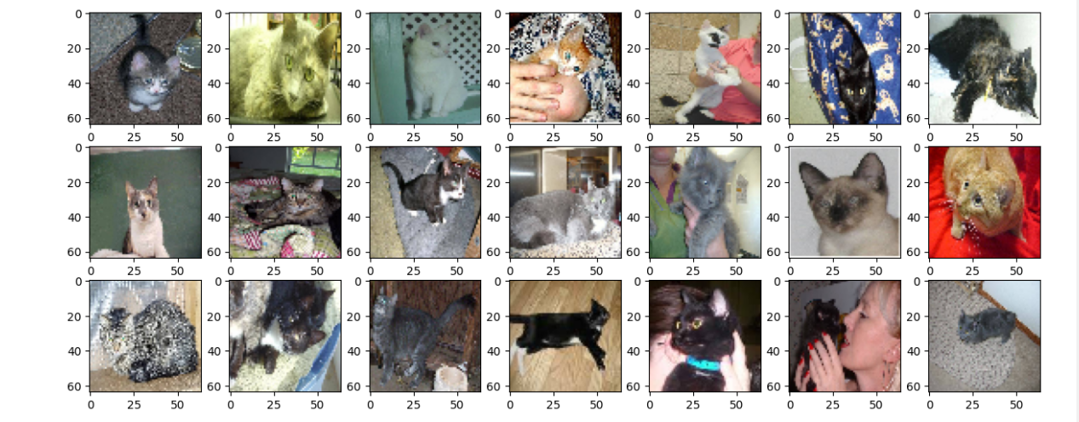

Displaying dogs img data

